DON'T BABY YOUR ENGINE
"Reprinted from AOPA Pilot Magazine"
Reproduced here in the interests of flight safety and engine longevity.

Some pilots do and the results are often quite discouraging. "Engine babyers" mean well by their engines, in fact they have been led to believe that by not using all of the available power for take-off and cruising with low power settings, they are conserving their engine. Usually this type of thinking is the result of experience with the stock automobile engine. In reality the aircraft engine has very little in common with the stock automobile engine in terms of operating procedures. The aircraft engine is the athlete of its species and it was designed for high power output. If this be the case, then you are not going to do it any disservice by using full power for take-off and 65 to 75% power for cruise. Even in view of these statements, many pilots are still reluctant to fly their engines at high power settings simply because they are still not convinced that such operation won't hurt the engine. If you are one of those pilots "not quite convinced" perhaps it would help if you knew what your engine had to do to prove itself before the FAA would grant a type certificate for its production.

Let's say that you are flying an airplane powered by a Teledyne Continental Motors Model 0-470-R engine. This engine, like any other, began on the drawing boards. From the drawing boards it became actual hardware and then it entered the developmental stage. Now a period of considerable testing and refinement follows until an engine ready for production finally emerges. However, before actual production and subsequent sale of this engine can begin, it must pass an FAA type test. The first production engine off the assembly will usually be the type test engine and here is what a type test involves.

The type test engine is mounted in a test cell and given a standard production acceptance test. After completion of this series of runs, the engine is ready to begin its type test (also called an endurance run). The engine will now be operated at full power (maximum rated manifold pressure and maximum rated RPM) for a period of 50 hours. During this period, the engine's CHT and OT (cylinder head temperature and oil temperature) will be held at normal range (first 2/3 of the green arc on your airplane gauges).

Upon completion of the first 50 hours, the engine is checked and made ready for the second 50-hour period. During, the next 50 hours, the engine will continue at full power - only this 50 hours will be at red line CHT and OT. Imagine that! - fifty hours at "full bore" with red line temperatures.
The last 50-hour phase will be alternating sequences of 65 to 75% power and at red line CHT and OT. Often I am asked how we are able to control temperature with the engine running, especially at full power. Cooling shrouds are placed over the engine in the test cell and actual cooling air is supplied from an outside blower. The minimum number of hours required by your FAA is 150 and in the sequence just described. Engine manufacturers often exceed this figure by as much as two or three times simply for their own satisfaction that all is well and the engine is trouble free.

After all type test running is completed, the engine is removed from the test stand, completely disassembled and every part carefully examined. Each moving part is checked with measuring instruments to determine if any appreciable wear has taken place. Each part must be able to pass the blueprint specifications for new parts. Now let's sum all of this testing up in terms of pilot or owner benefits.

The type test engine operated for 100 hours at full power, 50 hours of this time at red line temperature and still another 50 hours at red line temperature during the 65 to 75% power run. A minimum of 150 hours total, often more and during all of that demanding operation, no parts failed and actual wear of moving parts was for all practical purposes, negligible. You would have to fly your engine six minutes every hour at full power and for 1000 hours just to equal that portion of the test. A type test is quite an achievement in the eyes of most pilots but it isn't to the engine manufacturer. The type test is simply proof that the engine is able to do the job for which it was designed, and that the materials from which it is constructed are equally capable.

Now let's talk about all the other production engines that will follow the type test engine. Each new production engine is given a standard production acceptance test. The last part of this test is the oil consumption run and is conducted at full throttle. The purpose of this test is initial seating of the piston rings to the cylinder walls. The run is conducted at full power because that is where greatest B.M.E.P. (Brake Mean Effective Pressure) occurs and a high B.M.E.P. is necessary for good piston ring break-in. The test house at the factory determines initial piston ring seating by the amount of oil consumed by the engine during this run. Only a few hours are involved in the acceptance test and the new engine is by no means completely 'broken in." The finishing up break-in rests with the pilot who will be flying the engine during the first 100 hours of its life.

The cylinder walls of a new engine are not mirror smooth as one might imagine. A special hone is used to put a diamond like pattern of "scratches" over the entire area of the cylinder wall. Figure 1 shows a highly magnified view of these "scratches" (technically defined as cross hatch). The cross hatch treatment of the cylinder walls plays an important role in proper break-in of piston rings to cylinder walls. Earlier I mentioned that B.M.E.P.
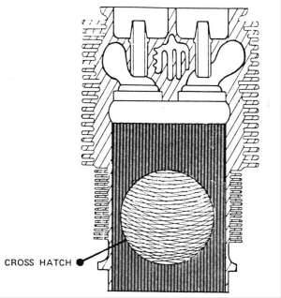
Figure 1. Above is a highly magnified view of the cross hatch pattern honed into the cylinder’s surface.

was necessary to the "break-in" process. Here is how it works.

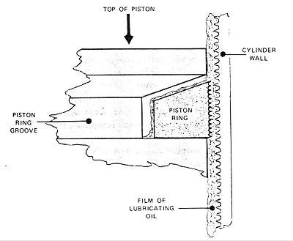
Figure 2. Notice the “saw teeth” like surface of the cylinder wall and piston ring face. In this illustration the piston ring is being held away from the cylinder wall by a film of lubricating oil. This drawing is considerable exaggerated in the interest of better understanding.

Figure 2 illustrates a cutaway of piston, ring and cylinder wall as these components would actually appear during normal operation in a new engine of very
little time. The illustration is considerable exaggerated for effect. In reality, the "saw teeth" effect would not be that pronounced. Notice that a film of lubricating oil holds the piston ring away from the cylinder wall. Proper break-in of piston ring to cylinder wall requires that the ring rupture or break through this oil film and make contact with the cylinder wall. During such "metal-to-metal" contact, the little peaks on the ring face and cylinder wall become white hot and rub off. This condition will continue to occur until the ring face and cylinder wall have established a smooth compatible surface between each other. At this point, break-in is said to be relatively complete and very little metal-to-metal contact will occur hereafter. In fact, as the break-in process progresses, the degree of metal-to-metal contact will regress.

There is one little "sticky wicky" in this process, that film of lubricating oil is there to prevent metal-to-metal contact. That's exactly what it will do and really that's what we want it to do. However, during the break-in process, we must have some minute metal-to-metal contact as previously explained. Therefore, rupture of the oil film is necessary. Two factors under the pilot's control can retard this necessary rupture ... low power and improper lubricating oils during the -break-in period. Engine lubricating oils can be divided into two basic categories, compounded (detergent and ashless dispersant) and non-compounded. The compounded oils are superior lubricants with a greater film strength than non-compounded oils. Consequently, only non-compounded oils should be used during the break-in period. Some owners insist on using additives or super lubricants along with the regular engine oil during the break-in period. They believe that such practice will aid the engine during its breaking in. With all due respect to such good intentions, this practice is wrong and actually causes harm.

Figure 3 is an exaggerated illustration of the oil film rupture during the normal break-in process. Note that the points or ridges of the honed-in scratches have partially worn away. During the actual oil-film rupture, only the ridges on the piston rings and cylinder walls contact each other. The little "valleys" between the ridges retain a film of oil and thereby prevent a total dry condition between piston ring and cylinder wall. B.M.E.P. or combustion pressure forces the ring against the cylinder wall. This is the "key" to the break-in process. You can see then that low power (low B.M.E.P.) won't provide the same results and the break-in process will require a longer period of time. However, time in this instance will have a detrimental effect on your engine because any prolonged, low power break-in procedure usually leads to "glazed" cylinder walls.

During each power stroke, the cylinder walls are subjected to very high temperatures, often 4000 degrees F or higher. This period is very brief but nevertheless, long enough to cause oxidation of minute quantities of some of the lubricating oil on the cylinder walls. Some of this oxidation will settle into the "valleys" of the honed cylinder wall "scratches." Eventually this situation will fill the "valleys" of the cylinder walls creating a smooth, flat surface. This is also a normal situation; however the ring break-in process practically ceases when these valleys become filled or "glazed" over.

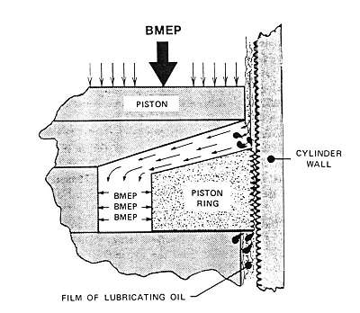If this "glazed over process occurs before break-in is complete, in modern day language, "you have had it." Excessive oil consumption resulting from incomplete ring seating will present itself and the only certain remedy is rehoning the cylinder walls. This is both expensive and unnecessary.

Well now you know the whole story, so let's examine the few simple steps necessary for proper break-in of any new, remanufactured, major or top overhauled engine.

Pick a good quality, non-compounded aircraft engine lubricating oil and stay with it throughout the break-in period. Duration of the break-in period is usually defined as the first 50 hours or until oil consumption stabilizes.

Do drain and replace engine oil as often as recommended by your owner's manual. If operating conditions are unusually dusty or dirty, more frequent draining may be necessary. Remember, no one ever wore out an engine by changing oil too often. Oil changes are more critical during the break-in period than at any other time in the engine's life.

Do use full rated power and RPM for every take-off and maintain these settings until at least 400 feet of altitude above the departing runway is attained. At this point, reduce power to 75% and continue the climb to your cruising altitude.

Do maintain 65 to 75% power for all cruise operation during the break-in period. Avoid high altitude operation with non-supercharged engines during the break-in period. Altitudes in excess of 8000 feet density will not permit sufficient cruise power development with non-supercharged engines. Interrupt cruise power every 30 minutes or so with a smooth advance to full available manifold pressure and RPM for 30 seconds then return to original cruise settings (non-supercharged engines only). This procedure helps to hasten a good break-in. The procedures suggested in this paragraph apply primarily to the break-in period and are not necessary thereafter.

Avoid long power-off let downs especially during break-in period. Carry enough power during let down to keep cylinder head temperatures at least in the bottom of the green.

Keep ground running time to absolute minimum especially during warm weather. During the break-in period, it will be better to delay departure than to sit at the end of the runway for 15 minutes or more running in high ambient temperatures.

Be especially generous with mixture controls and cooling air during break-in. All take-offs should be with a full rich mixture except from altitudes in excess of 5000 feet and then take care to lean only enough to restore power lost from overly rich mixtures. Make your climbs just a little flatter in hot weather to assure adequate cooling air.

Follow these simple recommendations during break-in and your engine will reward you with a healthy service life. And above all "Don't Baby Your Engine During Its Break-In Period."

